**HT1.    Lab: CSS Positioning**

**1.1         Social Media**

Create a Web Page like the following.

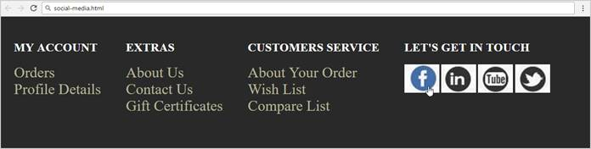

 Result:

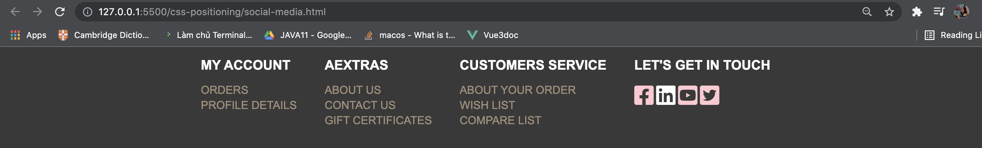

Create files: "**social-media.css**" and "**social-media.html**"

HTML:

<!DOCTYPE *html*>

<html *lang*="en">

<head>

<meta *name*="viewport" *content*="width=device-width, initial-scale=1.0" />

<link *rel*="stylesheet" *href*="social-media.css" />

<script

*src*="https://kit.fontawesome.com/1939b78ca2.js"

*crossorigin*="anonymous"

></script>

<title>social-media</title>

</head>

<body>

<div *class*="list-container">

<div *class*="child-container">

<h2>My Account</h2>

<ul *class*="list-child">

<li><a *href*="#">Orders</a></li>

<li><a *href*="#">Profile details</a></li>

</ul>

</div>

<div *class*="child-container">

<h2>AExtras</h2>

<ul *class*="list-child">

<li><a *href*="#">About Us</a></li>

<li><a *href*="#">Contact Us</a></li>

<li><a *href*="#">Gift Certificates</a></li>

</ul>

</div>

<div *class*="child-container">

<h2>Customers Service</h2>

<ul *class*="list-child">

<li><a *href*="#">About Your Order</a></li>

<li><a *href*="#">Wish List</a></li>

<li><a *href*="#">Compare List</a></li>

</ul>

</div>

<div *class*="child-container">

<h2>Let's Get in Touch</h2>

<ul *class*="list-child">

<li>

<a *href*="#"><i *class*="fab fa-facebook-square fa-2x"></i></a>

<a *href*="#"><i *class*="fab fa-linkedin fa-2x"></i></a>

<a *href*="#"><i *class*="fab fa-youtube-square fa-2x"></i></a>

<a *href*="#"><i *class*="fab fa-twitter-square fa-2x"></i></a>

</li>

</ul>

</div>

</div>

</body>

</html>

CSS:

body {

background-color: rgb(39, 39, 39);

color: white;

text-transform: uppercase;

font-family: Arial, Helvetica, sans-serif;

text-align: center;

padding: 0;

margin: 0;

}

*.list-container* {

display: inline-flex;

flex-direction: row;

justify-content: left;

}

*.child-container* {

margin-right: 50px;

}

*.child-container* h2 {

margin-left: 15;

text-align: left;

}

*.list-child* {

list-style: none;

text-align: left;

padding: 0;

}

*.list-child* li {

margin-bottom: 5px;

}

*.list-child* a {

font-size: 20px;

text-decoration: none;

color: rgb(150, 130, 107);

}

*.fab* {

color: pink;

}

*.fab:hover* {

color: white;

}

**1.2         Drop Down Menu**

Create a Web Page like the following

Result:

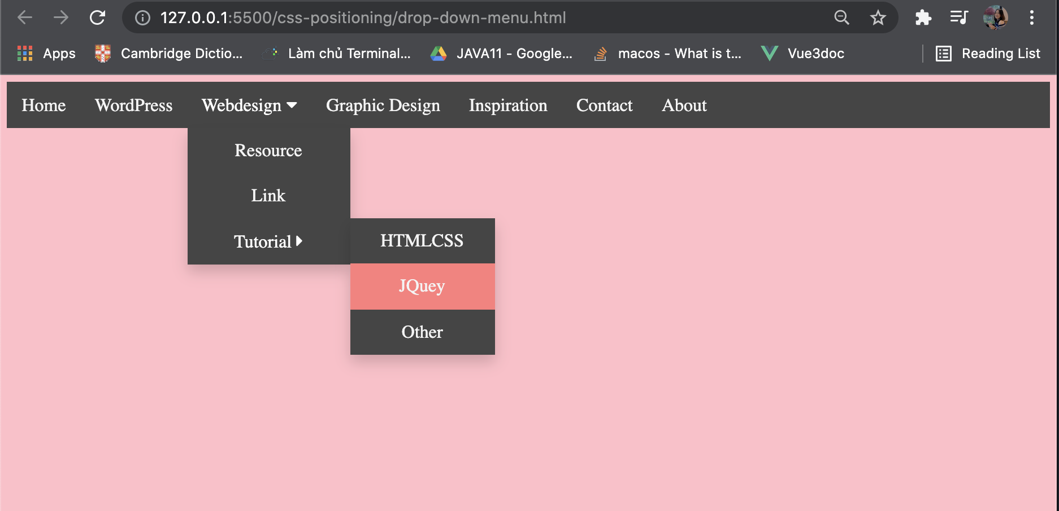

Create files: "**drop-down-menu.css**" and "**drop-down-menu.html**"

Default font: **"Open Sans", sans-serif**

[**http://fonts.googleapis.com/css?family=Open+Sans**](http://fonts.googleapis.com/css?family=Open+Sans)

Text Color:**#ffffff;**

Background Color: **#1d211e, #e67c1f**

***Code:***

HTML:

<!DOCTYPE *html*>

<html *lang*="en">

<head>

<meta *charset*="UTF-8" />

<meta *http-equiv*="X-UA-Compatible" *content*="IE=edge" />

<meta *name*="viewport" *content*="width=device-width, initial-scale=1.0" />

<title>Document</title>

<link *rel*="stylesheet" *href*="drop-down-menu.css" />

<script

*src*="https://kit.fontawesome.com/1939b78ca2.js"

*crossorigin*="anonymous"

></script>

</head>

<body>

<div *class*="navbar">

<a *href*="">Home</a>

<a *href*="">WordPress</a>

<div *class*="dropdown">

<button *href*="" *class*="dropbtn">

Webdesign <i *class*="fa fa-caret-down"></i>

</button>

<div *class*="dropdowncontent">

<a *href*="">Resource</a>

<a *href*="">Link</a>

<div *class*="dropdown dropright">

<button *href*="" *class*="dropbtn btn1">

Tutorial <i *class*="fa fa-caret-right"></i>

</button>

<div *class*="dropdown-menu">

<a *href*="">HTMLCSS</a>

<a *href*="">JQuey</a>

<a *href*="">Other</a>

</div>

</div>

</div>

</div>

<a *href*="">Graphic Design</a>

<a *href*="">Inspiration</a>

<a *href*="">Contact</a>

<a *href*="">About </a>

</div>

</body>

</html>

CSS:

body {

background-color: lightpink;

}

*.navbar* {

background-color: #333;

overflow: hidden;

width: 100%;

}

/* Style the links inside the navigation bar */

*.navbar* a {

font-size: 20px;

float: left;

display: block;

color: #f2f2f2;

text-align: center;

padding: 14px 16px;

text-decoration: none;

}

*.dropdown* {

float: left;

overflow: hidden;

}

*.dropdown* *.dropbtn* {

font-size: 20px;

border: none;

outline: none;

color: white;

padding: 14px 16px;

background-color: inherit;

font-family: inherit;

}

*.dropdowncontent* {

display: none;

position: absolute;

background-color: #333;

min-width: 160px;

box-shadow: 0px 8px 16px 0px rgba(0, 0, 0, 0.2);

z-index: 1;

}

*.dropdowncontent* a {

float: none;

padding: 14px 16px;

display: block;

text-decoration: none;

text-align: center;

}

*.dropbtn:hover*,

*.dropbtn1:hover*,

a*:hover* {

background-color: rgb(250, 110, 110);

}

*.dropdown:hover* *.dropdowncontent* {

display: block;

}

*.dropdown-menu* {

float: right;

display: none;

position: absolute;

background-color: #333;

min-width: 160px;

box-shadow: 0px 8px 16px 0px rgba(0, 0, 0, 0.2);

z-index: 1;

}

*.dropdown* *.btn1* {

width: 180px;

height: 50px;

text-align: center;

}

*.dropright:hover* *.dropdown-menu* {

display: block;

margin-left: 180px;

top: 100px;

}

*.dropdown-menu* a {

float: none;

}

**1.3         Floating Elements**

Create a Web Page like the following.

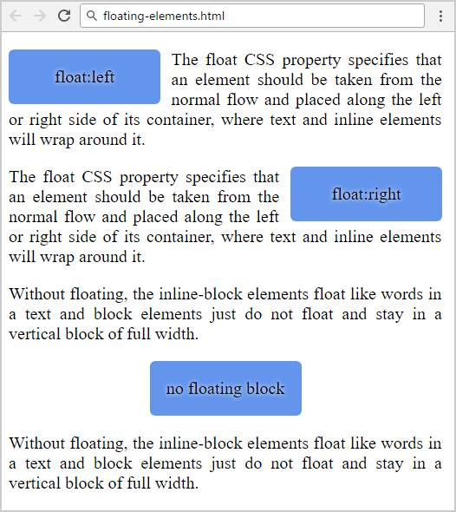

Create files: "**floating-elements.css**" and "**floating-elements.html**"

Result:



Use **Semantic tags**

**Code:**

Html:

<!DOCTYPE *html*>

<html *lang*="en">

<head>

<meta *charset*="UTF-8" />

<meta *http-equiv*="X-UA-Compatible" *content*="IE=edge" />

<meta *name*="viewport" *content*="width=device-width, initial-scale=1.0" />

<title>Document</title>

<link *rel*="stylesheet" *href*="floating-element.css" />

</head>

<body>

<article *class*="content">

<div *class*="float left">

<p>float-left</p>

</div>

<p>

The float property specifies whether an element should float to the

left, right, or not at all. Absolutely positioned elements ignore the

float property!Elements next to a floating element will flow around it.

To avoid this, use the clear property or the clearfix hack (see example

at the bottom of this page). The element floats to the left of its

container

</p>

</article>

<article *class*="content">

<div *class*="float right">

<p>float-right</p>

</div>

<p>

The float property specifies whether an element should float to the

left, right, or not at all. Absolutely positioned elements ignore the

float property!Elements next to a floating element will flow around it.

To avoid this, use the clear property or the clearfix hack (see example

at the bottom of this page). The element floats to the left of its

container

</p>

</article>

<article *class*="content">

<p>

The float property specifies whether an element should float to the

left, right, or not at all. Absolutely positioned elements ignore the

float property!Elements next to a floating element will flow around it.

To avoid this, use the clear property or the clearfix hack (see example

at the bottom of this page). The element floats to the left of its

container

</p>

<div *class*="float center"><p>float-center</p></div>

<p>

The float property specifies whether an element should float to the

left, right, or not at all. Absolutely positioned elements ignore the

float property!Elements next to a floating element will flow around it.

To avoid this, use the clear property or the clearfix hack (see example

at the bottom of this page). The element floats to the left of its

container

</p>

</article>

</body>

</html>

CSS:

@import url("https://fonts.googleapis.com/css2?family=Poppins:ital,wght@0,100;0,700;1,200;1,700&display=swap");

body {

font-family: "Poppins", sans-serif;

width: 800px;

text-align: justify;

margin-left: auto;

margin-right: auto;

background-color: #333;

color: cornsilk;

}

*.content* {

border: 1px solid rgb(96, 96, 96);

border-radius: 15px;

margin: 15px;

text-align: justify;

}

*.content* p {

margin: 10px;

}

*.float* {

background-color: lightblue;

color: rgb(19, 48, 115);

font-weight: bold;

width: 120px;

height: 60px;

text-align: center;

}

*.left* {

float: left;

margin: 10px 10px 0 10px;

}

*.right* {

float: right;

margin: 10px 10px 0 10px;

}

*.center* {

float: none;

margin-left: auto;

margin-right: auto;

}

**1.4         Clear Floating**

Create a Web Page like the following.

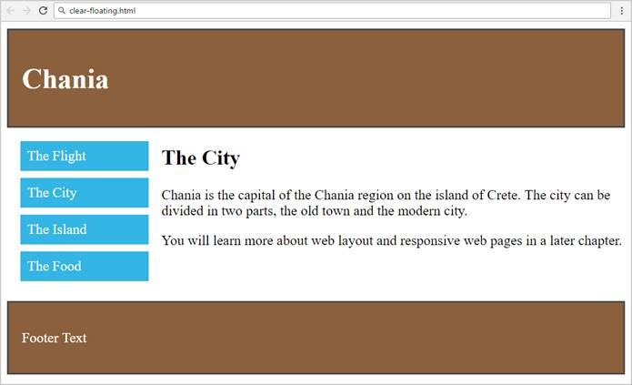

Create files: "**clear-floating.css**" and "**clear-floating.html**"

Use **Semantic tags**

**Result:**

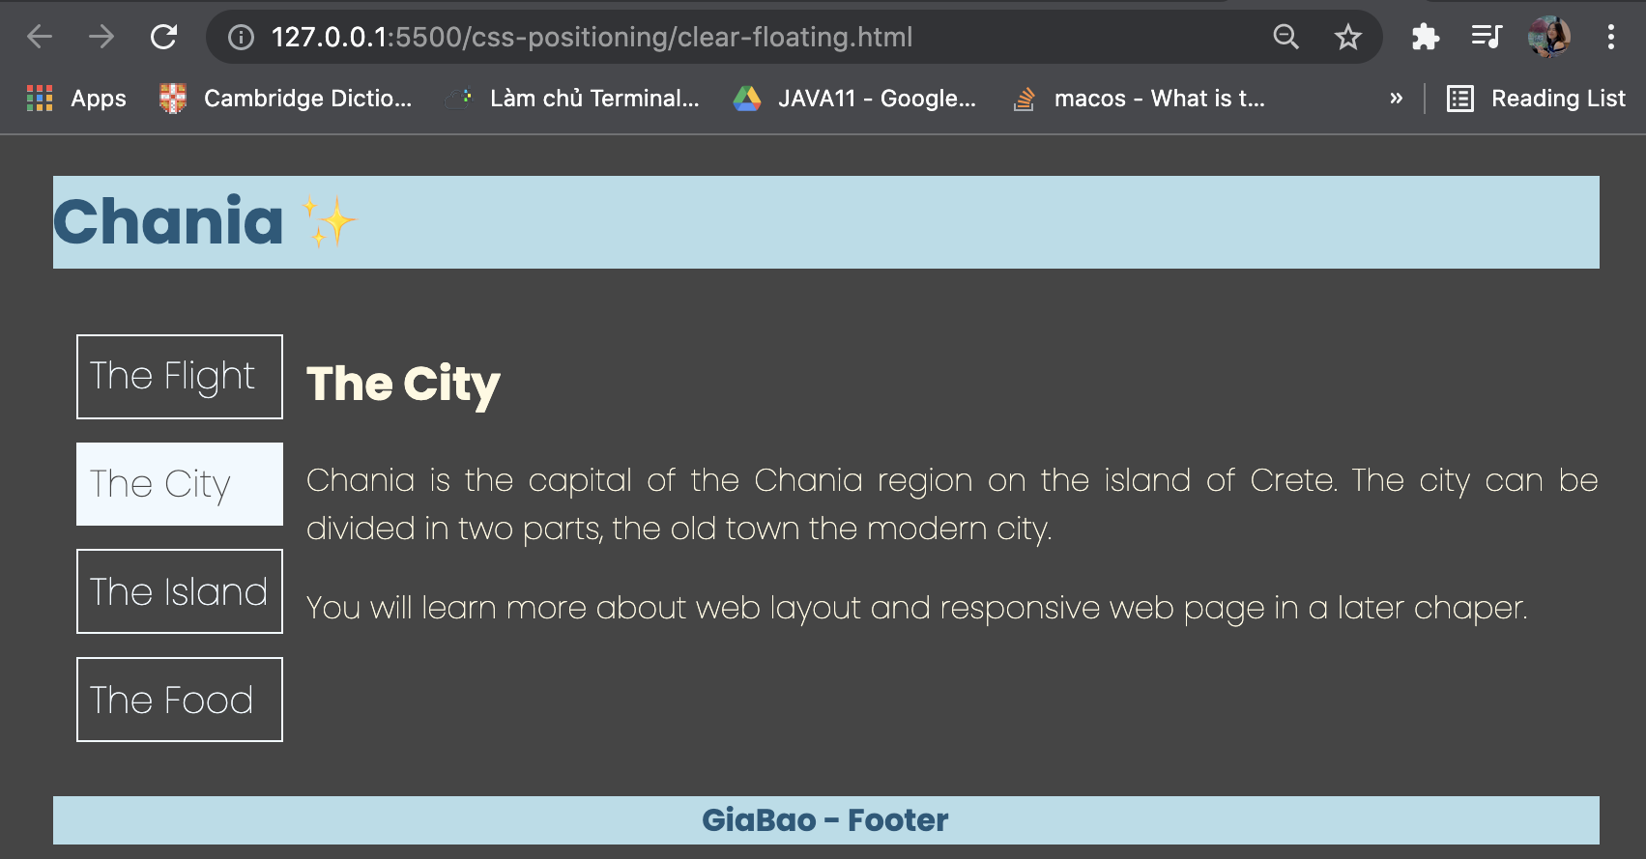

***Code:***

**HTML:**

<!DOCTYPE *html*>

<html *lang*="en">

<head>

<meta *charset*="UTF-8" />

<meta *http-equiv*="X-UA-Compatible" *content*="IE=edge" />

<meta *name*="viewport" *content*="width=device-width, initial-scale=1.0" />

<title>Document</title>

<link *rel*="stylesheet" *href*="clear-floating.css" />

</head>

<body>

<header>

<h1>Chania ✨</h1>

</header>

<div *class*="container">

<div *class*="float-list">

<a *href*="">The Flight</a>

<a *href*="">The City</a>

<a *href*="">The Island</a>

<a *href*="">The Food</a>

</div>

<div *class*="content">

<h2>The City</h2>

<p>

Chania is the capital of the Chania region on the island of Crete. The

city can be divided in two parts, the old town the modern city.

</p>

<p>

You will learn more about web layout and responsive web page in a

later chaper.

</p>

</div>

</div>

<footer>

<p>GiaBao - Footer</p>

</footer>

</body>

</html>

**CSS:**

@import url("https://fonts.googleapis.com/css2?family=Poppins:ital,wght@0,100;0,700;1,200;1,700&display=swap");

body {

font-family: "Poppins", sans-serif;

width: 1000px;

text-align: justify;

margin-left: auto;

margin-right: auto;

background-color: #333;

color: cornsilk;

font-size: 20px;

}

*.container* {

overflow: auto;

}

*.container* *.float-list* {

float: left;

}

*.container* *.float-list* a {

display: flex;

flex-direction: row;

text-decoration: none;

color: aliceblue;

font-size: 24px;

border: 1px solid aliceblue;

margin: 15px;

padding: 8px;

}

*.container* *.float-list* a*:hover* {

background-color: aliceblue;

color: #333;

}

*.container* *.content* {

margin-left: 160px;

}

header {

background-color: lightblue;

color: rgb(16, 73, 108);

}

footer {

background-color: lightblue;

width: 100%;

text-align: center;

color: rgb(16, 73, 108);

font-weight: 700;

}